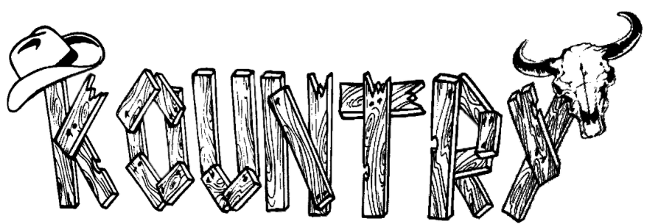Bar & Grill 315-332-8672
The
ENTREES

BURGER W/FF 9 RUBBISH PLATE 10

lettuce tomato cheese .50
onion rings (2) .50
bacon 1.00
jalapeno's .75
mushrooms .75
STEAK HOAGIE 9
shaved steak sandwich w/ cheese, peppers & onions
BLT W/FF 6
bacon, lettuce, tomato
CHICKEN PARM SANDWICH W/FF 8
Grilled or chicken finger w/marinara & Mozzarella cheese
burger or chicken fingers w/mac salad
and FF topped with meat sauce
QUESADILLA W/FF 11
Your Choice: STEAK or CHICKEN

cheese, green peppers, onion
tomatoes w/ sour cream & salsa

WRAPS W/FF 10

Your Choice: STEAK or CHICKEN cheese, green peppers, onion, tomatoes, lettuce
Veggie Wrap 8
cheese, green peppers, onion, tomatoes, lettuce

PIZZA W/CHEESE (8) (12 in) (16 in)
4.50 8 10
CHICKEN SANDWICH W/FF | 7 | add | pepperoni | .25 | .50 | .75
Grilled or chicken finger with |  |  | sausage | .25 | .50 | .75
lettuce & tomato |  |  | mushrooms | .25 | .50 | .75

CHICKEN FINGERS W/FF 8
- Chicken fingers w/sauce
jalapeno's .25 .50 .75
Onions .25 .50 .75
Black Olive .25 .50 .75
SHRIMP IN BASKET W/FF | 8 | Green Pepper .25 | .50 | .75
21 shrimp w/cocktail sauce |  | Bacon 75 | 1.00 | 1.25

substiute fries for onion rings $1.25, waffle fries or tator tots $1.00

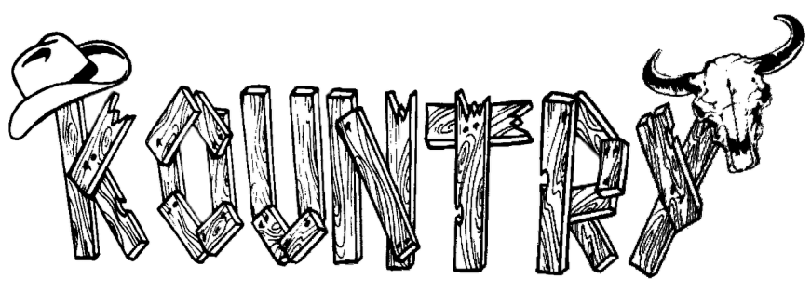SALADS
The
Bar & Grill

SIDE SALAD 4 STEAK SALAD 8

Lettuce, tomato, onion, croutons w/dressing

CHICKEN SALAD 7
Salad with Grilled or chicken finger on top
Salad with steak on top

B.L.T. SALAD 6
Salad with real bacon on top

STARTERS

JALAPENO POPPERS 5 PRETZEL STICKS 7
- poppers w/ranch 3 Bavarian Pretzel sticks w/ Beer Cheese

PICKLE STICKS 5
Battered Pickle Sticks w/ranch

MOZZ STICKS 5
5 Battered Mozzarella Sticks w/Marinara

CORN NUGGETS 6
D eep Fried Corn Nuggets

LOADED FRIES 6
Pile of Fries w/ Cheese, Bacon, Sour Cream

SIDES

MAC & CHEESE BITES 6
8 Mac & Cheese Bites w/Ranch

DEEP FRIED MUSHROOMS 7

PIZZA LOGS 5
4 Pizza Rolls w/Marinara

LIL BIT EVERYTHING 12
Choose 3 starters / with FF

ONION RINGS 5
MAC SALAD 3
FRENCH FRIES SMALL 3
LARGE 6
MEAT SAUCE 2.25

WINGS

TATOR TOTS 5

COLE SLAW 3

MAC & CHEESE 6
BEER CHEESE OR GRAVY 1.50

CHICKEN WINGS 13
12 Bone in Wings w/Blue Cheese
6 wings 7

BONELESS CHICKEN WINGS 13
12 Boneless wing w/Blue Cheese
6 Boneless Wings 7

